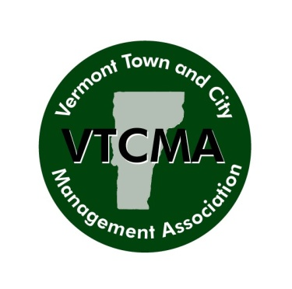
To: Managers, Town Administrators, VTCMA Members
From: Jeremy Weiss, VLCT Membership and Administrative Coordinator
Date: September 11, 2023
Re: Vermont Town & City Management Association
Distinguished Service & Outstanding Achievement Award Nominations
The Vermont Town and City Management Association (VTCMA) awards program shines the spotlight on the good work being undertaken by Vermont’s town and city managers, assistant managers, and town administrators. Particularly during these trying times including recent flooding affecting much of the State, there have been lots of dedicated service, innovative and hard work, and retirements to honor. VTCMA encourages excellence among all its members by highlighting examples of their exceptional work.

VTCMA is once again requesting nominations for Distinguished Service and Outstanding Achievement Awards. Municipal managers, assistant managers and municipal administrators are eligible award recipients. All nominations will be submitted to the VTCMA Awards Committee of the VTCMA Board of Directors for evaluation against the criteria established for each award.

Nomination forms and evaluation criteria are attached, as is a list of award recipients from years past. As you make your nomination, please keep these evaluation criteria in mind.

The deadline for submitting nominations is Wednesday, September 27, 2023.

Please email your nominations to JWeiss@vlct.org.

Award Descriptions

Distinguished Service. This award will be given to a Municipal Manager, Assistant Manager or Administrator who has demonstrated a history of leadership and integrity in one or more communities in Vermont. The nominee must also have provided service and leadership to organizations beyond their community such as VTCMA, VLCT, a regional commission or other regional group.

Outstanding Achievement. This award will be given to a Municipal Manager, Assistant Manager or Municipal Administrator in recognition of a particularly bold and innovative project or for solving an unusually difficult problem. Examples include a downtown revitalization project, new and innovative ways of providing everyday services such as public safety or recreation, bringing peace to a community after a particularly divisive issue, or finding a creative solution to a difficult problem. Any project or effort that benefits a community or group of communities may be considered for this award. The nominee must have played a key role in developing the project as well as implementing it. The nominee may be self nominated or nominated by staff, peers, citizens or elected officials.

Eligibility
Current, full members of the VTCMA are eligible for these awards.

Evaluation Criteria

Distinguished Service
1. Must be current, full member of VTCMA.
2. Shall not be past recipient of Distinguished Service Award.
3. Minimum of six years of service as the chief administrative officer or similar position for a community.
4. Employment as a professional municipal manager at the time of the award selection or recently retired.
5. Has made significant contributions toward excellence in leadership and demonstrated personal integrity while serving as the chief administrative officer or in similar position.
6. Service and contributions beyond that of the municipality or municipalities in which the nominee has served.

Outstanding Achievement
1. Must be current, full member of VTCMA.
2. Nomination must describe the project and the nominee’s role in the project.
3. Project should be a particularly bold or innovative solution to an unusually difficult problem.
4. The nominee must have played a key role in developing and implementing the project.

Application
Please complete the appropriate form included with these guidelines

Deadline
Please remit all nominations to Jeremy Weiss, Membership and Administrative Coordinator, Vermont League of Cities and Towns, 89 Main Street, Suite 4, Montpelier, VT 05602, or JWeiss@vlct.org by Wednesday, September 27, 2023.

Award Notification
Award recipients will be announced at the VTCMA Fall Conference dinner, Thursday, October 26, at the Sugarbush Mountain Resort in Warren, Vermont.

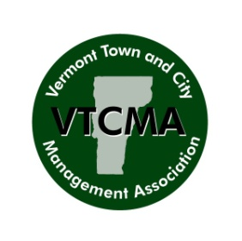
VTCMA Outstanding Achievement Award

1. Nomination submitted by:

Name/Office Held
E-mail
Municipality
Telephone

2. Name of Nominee: ________________________________________________

3. Explain the problem addressed by the project and why the problem was unusually difficult. (Use additional space if required.)

________________________________________________________________________
________________________________________________________________________
________________________________________________________________________
________________________________________________________________________
________________________________________________________________________
________________________________________________________________________
________________________________________________________________________

4. Describe the project and how it addressed the problem in an innovative or bold manner.
(Use additional space if required.)

________________________________________________________________________
________________________________________________________________________
________________________________________________________________________
________________________________________________________________________
________________________________________________________________________
________________________________________________________________________

5. Explain the nominee’s role in developing and implementing the project. (Use additional space if necessary.)

________________________________________________________________________
________________________________________________________________________
________________________________________________________________________
________________________________________________________________________
________________________________________________________________________
________________________________________________________________________
________________________________________________________________________
________________________________________________________________________

6. Please provide additional information that would help the Awards Committee make a selection. Examples include letters from others who support the nomination and newspaper clippings that reported on the project.

________________________________________________________________________________________________________________________________________________________________________________________________________________________________________________________________________________________________________________________________________________________________________

______________________________ _____________________________
Signature, Person Making Nomination Date

Please remit all nominations to Jeremy Weiss, Membership and Administrative Coordinator, Vermont League of Cities and Towns, 89 Main Street, Suite 4, Montpelier, VT 05602, or JWeiss@vlct.org by Friday, September 22, 2023.

VTCMA Distinguished Service Award

1. Nomination submitted by:
Name/Office Held
Email
Municipality
Telephone

2. Name of Nominee: ______________________________________________________

3. Nominee has ____________ years of service as a chief administrative officer in Vermont.

4. Nominee is currently employed as a municipal manager or administrator. Yes No

5. Describe how the nominee has exemplified qualities of integrity and leadership.
(Use additional sheets of paper, if required.)

________________________________________________________________________
________________________________________________________________________
________________________________________________________________________

6. Identify the organizations, outside of the municipality, in which the nominee has served
and where possible, the length of service. (Use additional space if necessary.)

____________________________________________________________________________

____________________________________________________________________________

____________________________________________________________________________

______________________________ _____________________________
Signature, Chief Elected Officer Date

Please remit all nominations to Jeremy Weiss, Membership and Administrative Coordinator, Vermont League of Cities and Towns, 89 Main Street, Suite 4, Montpelier, VT 05602, or JWeiss@vlct.org by Friday, September 22, 2023.

